OOP Quiz 4 Sec E: (3/5/19)

Remove error (if any) from this code and then write the output

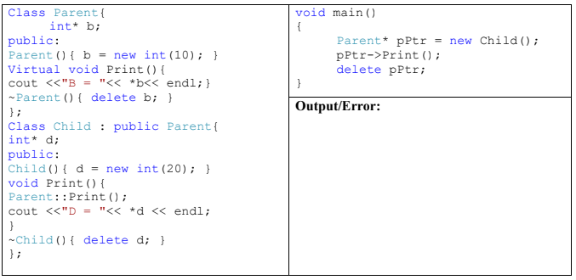

OOP Quiz 4 Sec F(3/5/19)

